SUPPORTING INFORMATION
Location, Average Orientation and Dynamics of Amino Acids in a Membrane Mimetic: ²H-NMR and Molecular Dynamics Study
Enzo Cevo*, Amatista San Martín Bojórquez*, Diego Muñoz-Gacitúa and Boris Weiss-López
*Corresponding author
Unless stated otherwise, all simulated quantities are averaged over the 100–200 ns interval of each trajectory in five 20 ns blocks, and uncertainties are standard errors over those blocks.
S1. Experimental ²H NMR quadrupolar splittings
Table S1. Experimental ²H NMR quadrupolar splittings (Δν_{Q}) in Hz for the CD₂ and CD₃ segments of SDS-d₂₅ in samples S1–S5 at 310 K, together with the variation ΔM of each carbon relative to the amino-acid-free control S1. Carbon numbering runs from C1, bonded to the sulfate ester oxygen, to C12, the terminal methyl. This assignment is reversed with respect to the one given in the previous version of this work: the chain order profile obtained from the simulations correlates with the present assignment at r = 0.992 and is anticorrelated (r = −0.46) with the previous one, and the four degenerate entries can only correspond to the unresolved plateau near the head group, not to a terminal methyl. Carbons sharing a value within a sample correspond to lines that are not resolved: each sample yields seven distinct splittings, not twelve.
C | S1 (no AA) | S2 (ALA) | ΔM | S3 (GLU) | ΔM | S4 (LEU) | ΔM | S5 (MET) | ΔM
C1 | 14485 | 14333 | +152 | 12989 | +1496 | 12740 | +1745 | 12765 | +1720
C2 | 14485 | 14333 | +152 | 12989 | +1496 | 12740 | +1745 | 12765 | +1720
C3 | 14485 | 14333 | +152 | 12989 | +1496 | 12740 | +1745 | 12765 | +1720
C4 | 14485 | 14333 | +152 | 12522 | +1963 | 12740 | +1745 | 12765 | +1720
C5 | 13896 | 13810 | +86 | 12263 | +1633 | 12218 | +1678 | 12249 | +1647
C6 | 13896 | 13810 | +86 | 12263 | +1633 | 11759 | +2137 | 11754 | +2142
C7 | 13273 | 13185 | +88 | 12263 | +1010 | 11759 | +1514 | 11754 | +1519
C8 | 13273 | 13185 | +88 | 12263 | +1010 | 11759 | +1514 | 11754 | +1519
C9 | 11748 | 11697 | +51 | 10903 | +845 | 10469 | +1279 | 10488 | +1260
C10 | 10108 | 10082 | +26 | 9422 | +686 | 8999 | +1109 | 9033 | +1075
C11 | 7652 | 7659 | −7 | 7108 | +544 | 6835 | +817 | 6824 | +828
C12 | 2284 | 2265 | +19 | 2080 | +204 | 2024 | +260 | 2047 | +237

Table S2. Experimental ²H NMR quadrupolar splittings (Δν_{Q}) in Hz measured for the selectively deuterated amino acids associated with the liquid-crystalline aggregates. GLU-d₅ yields five resolved lines, listed without assignment.
Sample | Deuterated amino acid | Δν_{Q} / Hz
S6 | ALA-d4 | 440.61
S7 | GLU-d5 | 103.00
S7 | GLU-d5 | 341.53
S7 | GLU-d5 | 540.90
S7 | GLU-d5 | 701.90
S7 | GLU-d5 | 1765.10
S8 | LEU-d3 | 580.00
S9 | MET-d3 | 788.00
S2. Quantities derived from the simulations
Table S3. Resolved reorientational correlation times (ps) of the SDS C–H vectors, per chain position and for the chain as a whole, in the control and in the four amino-acid-containing systems. The last two rows give the pooled C1–C11 methylene vectors and the C1→C12 molecular axis. These are the resolved, slow component of the decay and therefore upper bounds on τ_{c}: the first measurable lag is 20 ps and between 59 % and 99 % of the decay occurs below it. No difference between the control and any amino-acid system exceeds 2.1 standard errors.
Position | control | ALA | GLU | LEU | MET
C1 | 203 ± 4 | 208 ± 2 | 210 ± 4 | 211 ± 4 | 204 ± 3
C2 | 175 ± 2 | 176 ± 1 | 177 ± 3 | 178 ± 2 | 175 ± 3
C3 | 154 ± 2 | 154 ± 2 | 156 ± 1 | 157 ± 1 | 153 ± 2
C4 | 156 ± 1 | 158 ± 2 | 163 ± 4 | 161 ± 2 | 157 ± 2
C5 | 139 ± 1 | 140 ± 2 | 143 ± 3 | 140 ± 2 | 139 ± 2
C6 | 135 ± 2 | 138 ± 2 | 138 ± 3 | 137 ± 2 | 138 ± 2
C7 | 130 ± 2 | 131 ± 3 | 136 ± 4 | 131 ± 3 | 134 ± 4
C8 | 131 ± 3 | 132 ± 3 | 137 ± 4 | 132 ± 3 | 132 ± 3
C9 | 120 ± 2 | 120 ± 4 | 126 ± 5 | 119 ± 3 | 122 ± 3
C10 | 111 ± 1 | 112 ± 4 | 120 ± 4 | 112 ± 2 | 114 ± 4
C11 | 73 ± 3 | 75 ± 2 | 77 ± 3 | 75 ± 2 | 77 ± 1
C12 | 68 ± 5 | 62 ± 4 | 66 ± 8 | 69 ± 4 | 69 ± 7
C1–C11 | 151 ± 1 | 153 ± 2 | 156 ± 3 | 154 ± 1 | 152 ± 2
C1→C12 axis | 486 ± 6 | 494 ± 12 | 504 ± 13 | 496 ± 5 | 485 ± 10

Table S4. Quadrupolar splittings calculated from the simulations, Δν_{Q} = (3/8)(e²qQ/h)|S_{CD}| with e²qQ/h = 167 kHz. The second column gives the absolute value for the amino-acid-free control; the remaining columns give the change on adding each amino acid, with its significance in standard errors in parentheses. No calculated change reaches one standard error, whereas the measured changes of Table S1 reach 2142 Hz.
C | Control, simulated | ALA | GLU | LEU | MET
C1 | 18853 ± 57 | +56 (0.7) | +30 (0.3) | −24 (0.3) | +52 (0.7)
C2 | 15243 ± 87 | +124 (1.0) | +147 (1.0) | +89 (0.6) | +39 (0.3)
C3 | 13837 ± 92 | +42 (0.3) | +159 (1.0) | +90 (0.5) | +2 (0.0)
C4 | 18158 ± 119 | +40 (0.2) | +96 (0.6) | +16 (0.1) | −3 (0.0)
C5 | 16257 ± 164 | +70 (0.3) | +121 (0.5) | +61 (0.2) | −20 (0.1)
C6 | 16850 ± 169 | +87 (0.4) | +148 (0.6) | +92 (0.4) | −46 (0.2)
C7 | 15688 ± 171 | +87 (0.4) | +121 (0.5) | +98 (0.4) | −42 (0.2)
C8 | 15796 ± 175 | +81 (0.3) | +99 (0.3) | +85 (0.3) | −51 (0.2)
C9 | 13796 ± 183 | +80 (0.3) | +115 (0.4) | +81 (0.3) | −52 (0.2)
C10 | 12276 ± 169 | +58 (0.2) | +99 (0.4) | +79 (0.3) | −81 (0.4)
C11 | 6972 ± 130 | +39 (0.2) | +40 (0.2) | +57 (0.3) | −33 (0.2)
C12 | 1549 ± 35 | +8 (0.2) | +11 (0.2) | +10 (0.2) | −0 (0.0)

Table S5. Published hydrophobicity scales compared with the quantities obtained here. ΔG_{wif} and ΔG_{woct} are the interfacial and octanol scales of Wimley and White; π is the octanol–water side-chain parameter of Fauchère and Pliška. Negative ΔG and positive π denote hydrophobic character. Taking ΔG_{wif} as reference, the Spearman rank correlation is −1.00 for the contact fraction, +1.00 for the hydrogen bonds to water, +1.00 for the lateral diffusion coefficient, −1.00 for the residual orientational order and +0.80 for the side-chain depth, the single inversion being the LEU/MET pair, which the simulations do not resolve either.
 | LEU | MET | ALA | GLU⁻
ΔG_{wif} / kcal mol⁻¹ | −0.56 | −0.23 | +0.17 | +2.02
ΔG_{woct} / kcal mol⁻¹ | −1.25 | −0.67 | +0.50 | +3.63
Fauchère–Pliška π | +1.70 | +1.23 | +0.31 | −0.64
Contact fraction f_{b} | 1.00 | 0.97 | 0.93 | 0.65
Side-chain density max. / nm | 1.14 | 1.02 | 1.74 | 1.98
H-bonds with water | 2.92 | 3.41 | 3.96 | 9.42
D_{lat} / 10⁻⁷ cm² s⁻¹ | 4.1 | 7.9 | 19.2 | 58.7
Residual order of the Cα→side-chain axis | 0.64 | 0.40 | 0.06 | 0.00

S3. Supplementary figures
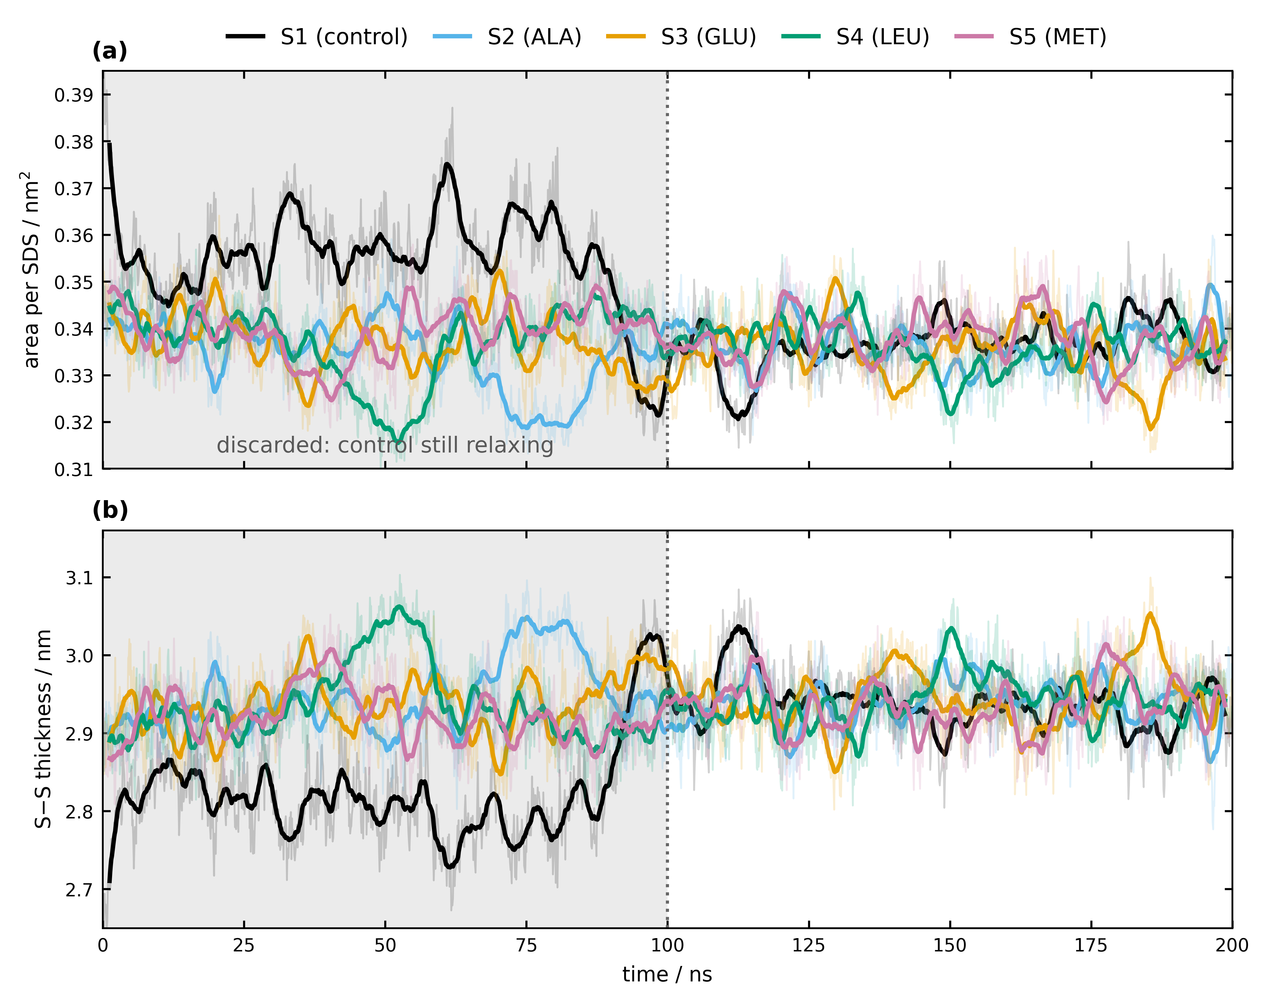
Figure S1. Area per SDS molecule (a) and sulfur–sulfur bilayer thickness (b) against time for the five systems. Thin traces are per-frame values, thick traces a 25-frame moving average. The shaded region is discarded from all analysis. The control contracts abruptly between 85 and 95 ns and only then matches the four amino-acid-containing systems, which are stationary from the start; over the 50–200 ns window used previously this residual difference produces an apparent ΔS_{CD} of +0.010 that correlates with the difference in area at R² = 0.997. All results reported here use 100–200 ns.

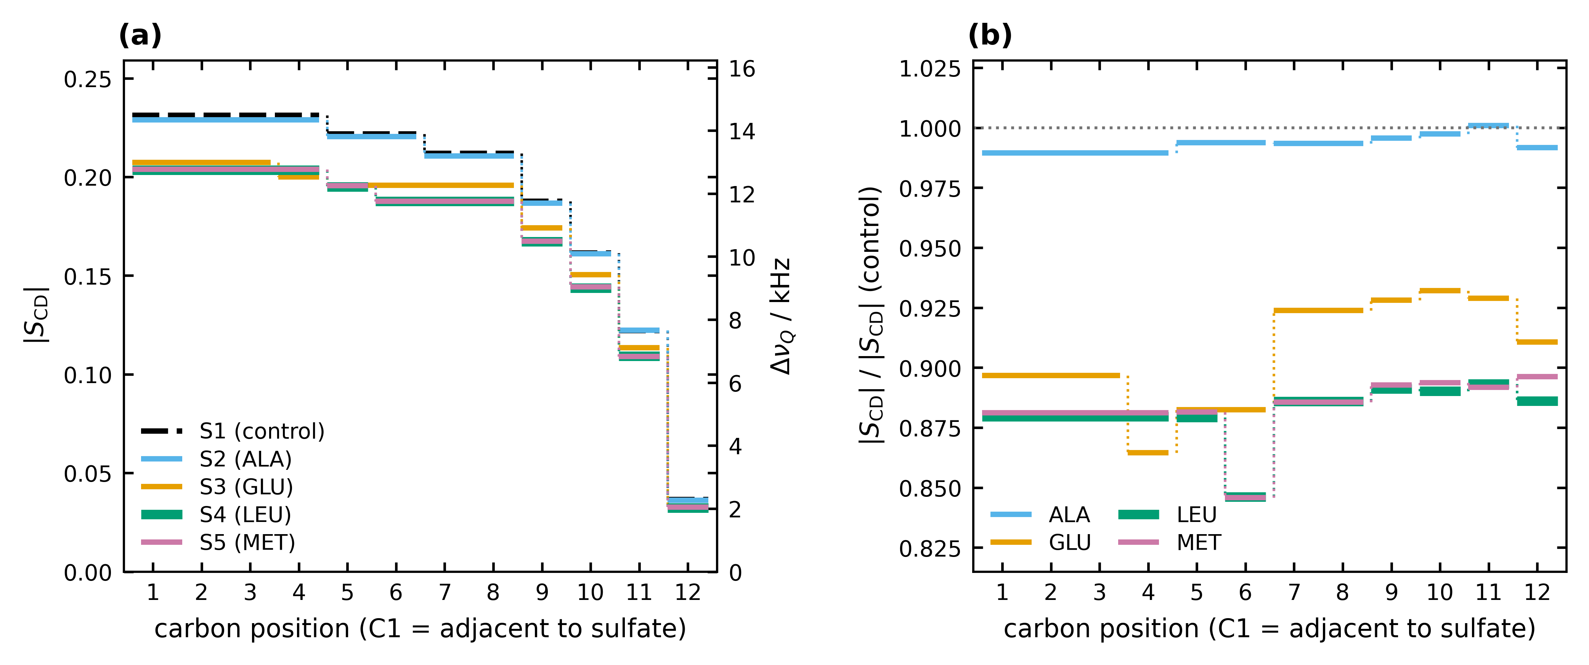
Figure S2. ²H NMR order parameters of the SDS chain in the four amino-acid-containing samples, obtained from the splittings of Table S1 through |S_{CD}| = Δν_{Q} / 62 625 Hz. (a) Absolute profiles with the amino-acid-free control for reference; each value is drawn as a segment spanning the carbons that report it. (b) The same data as a ratio to the control. The effect is close to multiplicative rather than localised: LEU and MET reduce the order parameter by a nearly constant factor along the whole chain (0.881 ± 0.012 and 0.883 ± 0.013), GLU by 0.906 ± 0.021, and ALA is indistinguishable from the control (0.993 ± 0.003).

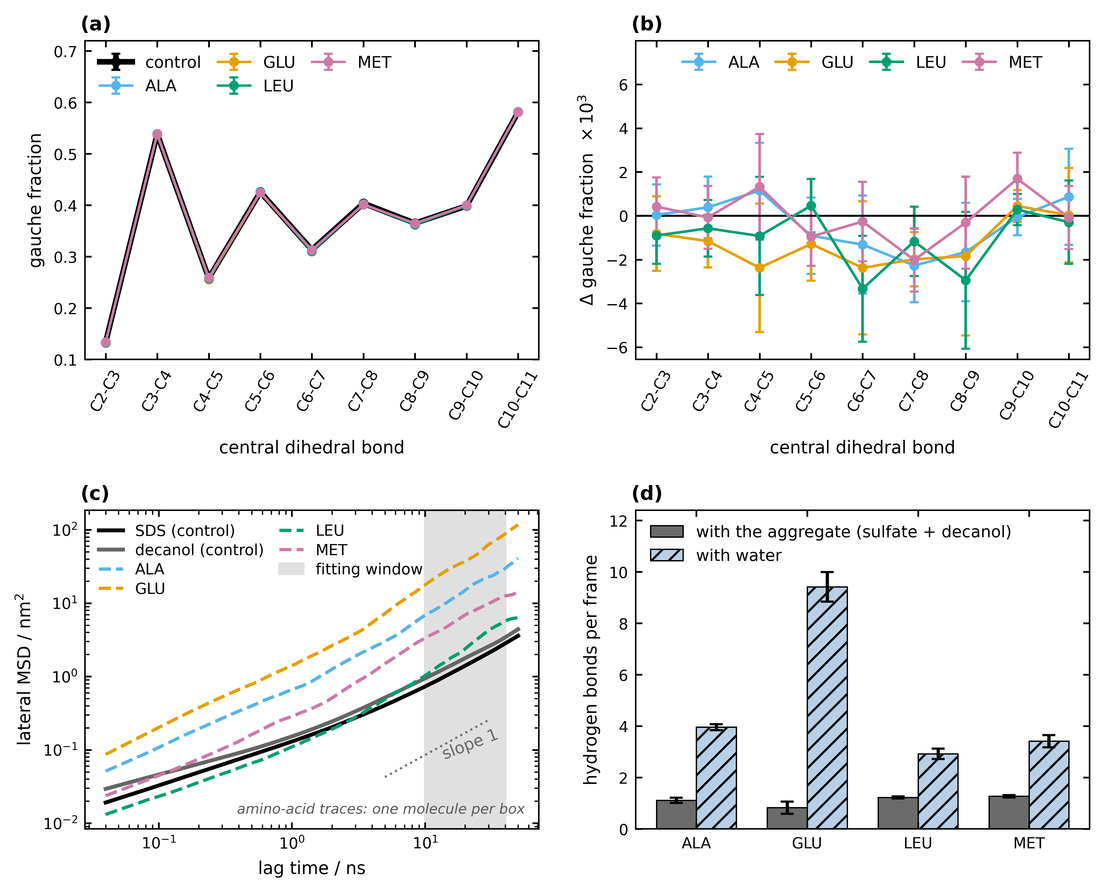
Figure S3. (a) Gauche fraction of each C–C–C–C dihedral of the SDS chain; the five curves superimpose. (b) The same quantity as a difference against the control: all four amino acids are zero within one standard error. (c) Lateral mean-square displacement of the host amphiphiles and of the four amino acids, with the centre of mass of each monolayer removed separately; the shaded region is the fitting window, where the log–log slope is 0.83–1.02. (d) Hydrogen bonds of the amino acid per frame, with the aggregate and with water (d(D···A) ≤ 0.35 nm, ∠D–H···A ≥ 150°).

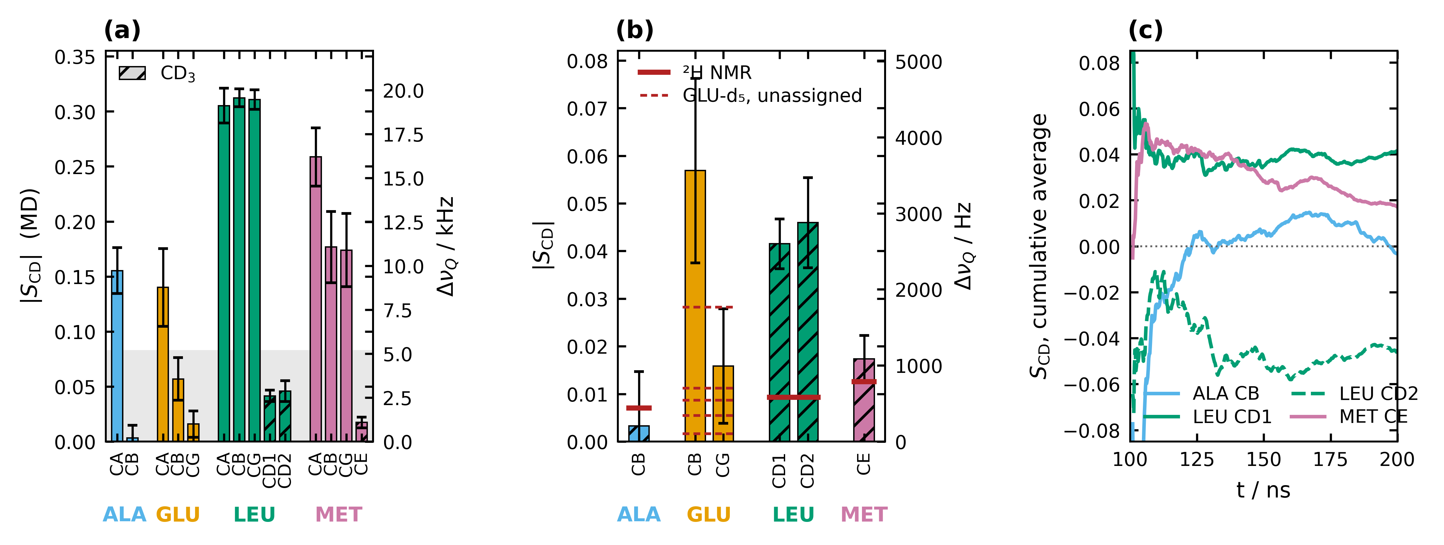
Figure S4. Order parameters of the amino acids themselves. (a) |S_{CD}| from the simulations for every non-exchangeable C–H position; hatched bars are methyl groups. (b) The same on the scale of the positions the experiment reports, with the splittings of Table S2 in red. (c) Cumulative time average for the labelled methyls. Only MET agrees quantitatively. Panel (c) identifies the cause as sampling rather than force field: the two chemically equivalent methyls of LEU converge to order parameters of opposite sign, which cannot happen in a converged ensemble average.

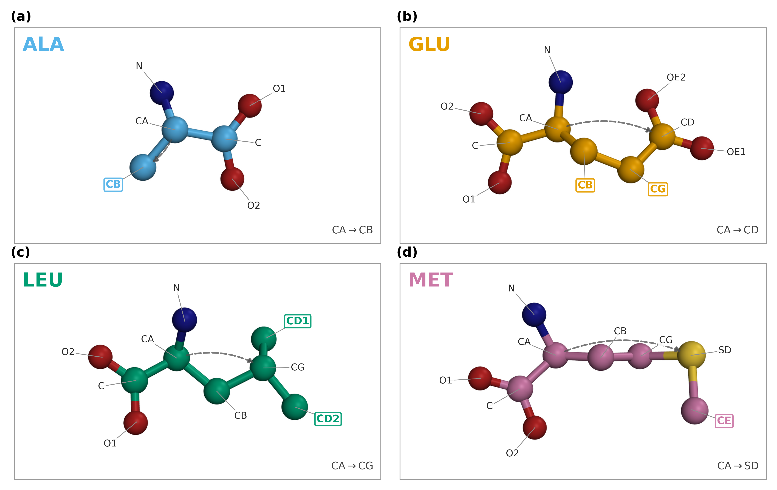
Figure S5. Heavy-atom naming of the four amino acids, as used throughout the text and figures. Boxed bold labels mark the deuterated positions of the ²H-labelled compounds. The dashed arrow is the Cα→side-chain vector whose angle with the monolayer normal defines θ. Each panel is a real frame of the corresponding trajectory, chosen so that no two non-bonded heavy atoms overlap in projection; the conformations are chosen for legibility of the naming and are not representative of the populated states.

